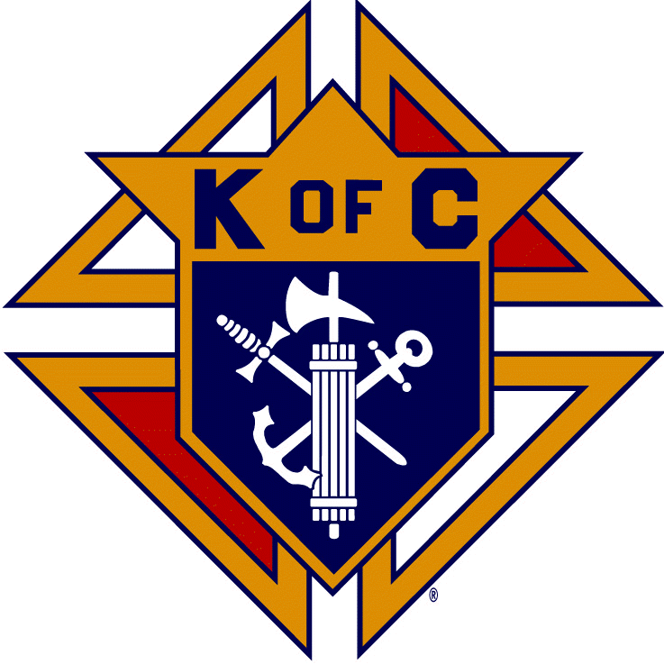

Knights of Columbus / Chevaliers de Colomb
Nova Scotia State Council
Conseil d’Etat Nouvelle-Ecosse

State University Membership Report

APRIL 13, 2020

AGENDA

PREMISE – Pros and Cons
OUTLINE
MEETINGS
FAILURES
SUCCESSES
MARCH MEETING
GOING FORWARD
TIMELINE

E-3
Premise
The basic idea was to set up a State Round Table for HRM Adult students from Universities – Colleges – Trade schools etc. This would allow them to work with any HRM council they wanted to while still being able to do what interested them.
Issues
Our problem from the start was our inability to connect with students on campus. We had hoped to partner with CCO who are established at the Universities. We thought we had an individual that could help us however this did not work out as it appears CCO is looking at us as a funding partner which we are not.
Meetings
We tried the traditional method of hosting an info dinner which fell flat as we are unable to get the word out.
We were successful in getting Mike Campbell, Facilities Manager at Dal, from Council 16817 St. Agnes, to head up the Round Table. We identified some potential recruits and a couple of Knights already on Campus however they were very relucted to make a commitment. Due to other commitments things drifted until first of March when we had a meeting with Fr. Craig the GK for St. Agnes and his Membership Chair.
As identified below our present target audience is not into our traditional methods of contact and info sharing instead, they operate fast and quickly through their Phones – I pads etc. and to connect with them we have to be able to operate in their world.
I do not have the computer – phone skills necessary (See Going forward) so as the meeting shows we are changing direction.
While we have had few successes, we have been able to put a team together (Fr. Craig Cameron, Personnel Adviser Cory Garnier, RT Chair Mike Campbell, State Rep Sean Kelly and Supported by GK Peter Bonner of 16817

E-4

March Meeting
This meeting identified issues with our present approach and ways to move forward.
Object was to try and make contact with University youth before the end of semester.
Discussion then revolved around how these youth communicate and it was pointed out that all their communications were via their phones and if we wanted to communicate with them it would have to be through that medium.
This is okay but who or what groups should we target and why
Fr. Craig was able to enlighten us on 4 potential groups and he has agreed to furnish contact info for each
the Groups are: Greater Love, a University based group that helps feed the homeless, help the food banks and the poor in general. This group has the best potential as this is the type of thing the Knights do and thus is easy for us to support
Night Fever is put on at the Basilica, can attract from 40 to 4,000. We need to find out more and how we can help.
St. Catherine’s church, St. Benedict, St. Michael all have men’s groups that meet’s monthly.
Colby House is a campus gathering place for Catholic Students
As Cory pointed out we will have to establish 1 on 1 personal relationships based on how we can support them and their efforts. No pressure regarding membership but keeping them in the loop of programs and events that may interest them.
It was decided to approach 2, Greater Love and Night Fever and see if they wanted help, if so what was needed and proceed from there.
We have hit the reset button and are trying to engage within the medium they are most comfortable with and offer no commitment support for their efforts.
This will require a new team approach led by St. Agnes council 16817 which will now spearhead this effort with their team of GK Peter Bonner, Mike Campbell and Corey Garnier
Fr. Craig will continue as adviser and will forward contact info to Cory
Requests for help within the District and at State level and info on events will flow to Sean as the State Rep.

E-5

This reset requires a reset in thinking on behalf of the Knights and leaders such as myself.

This started out as a way to entice College men individually to join our order and we were gearing things towards that end because that’s what we know how to do. It didn’t work
Instead I believe we have to look at the organizations that are on campus doing work that we can relate to, like Greater love, and support them. We can also invite them to our major events.
The hope is that as they see that we support the same ideals that they do then as they transition from school to the working world, they will look to joining the Knights to continue their work of charity.

Sean will discuss with the other Metro DD’s how we can support St. Agnes in this endeavor

Shortly after this meeting the Covid -19 virus hit and everything is at a standstill so nothing will happen until August – Sept.
Sean will step back and Cory will become the Face of the RT along with Mike Campbell and Fr. Craig and will connect with the groups identified. We will work through Zoom to put a program and support package in place for Aug – Sept.

Sometimes we have to fail to move ahead and I believe this new approach in thinking and action will pay dividends down the road

Sean Kelly, State UNIV RT

E-6

